Agentic AI Hackathon – Instructions

 | - Before you start with the next steps, please ensure to sign-out of all AWS Accounts (including your organization owned ones) in your browser if you’ve already logged into any.  - Start with a clean browser with no other AWS account sign-ins. The AWS console works best on Firefox or Chrome browsers.  - Please DO NOT use “incognito”, “Guest”, “Private Browsing” or any other non-standard browser modes as the event may not load correctly.  - The AWS burner account sign-in link that you’ll receive through email is valid for your team only. Please DO NOT use any other team’s sign-in links as it’ll void your work.  - The event access will start at 9 AM local time on May 27th. If you try to access the event before it starts, you’ll see a message saying “Event not started Please wait until your facilitator starts the event.”  - The AWS burner accounts provisioned for this event are NOT meant for performance testing and cannot handle significant number of API calls. These accounts are meant for prototyping ONLY. Please be aware that your account may be put on hold if you’re initiating high number of API calls to AWS services.  - Max number participants allowed to login per team into the AWS burner account is 8. If you have more than 8 people in your team, then you’ll see a message stating max capacity reached.  - To maximize your time and Hackathon experience, be sure to review the recorded enablement sessions and training materials provided via emails and BeMyApp website.  - Be sure to take regular local backups of the code you’re building in the AWS console to prevent data loss in the event of an issue in your team’s account.  - If you have any questions please reach out to the mentors (AWS) onsite or virtual.  - AWS releases new service features all the time. If any of the screens captured in the instructions do not look the same, or if you have any questions, please reach out to the mentors for your location (onsite or virtual).

I know you’re excited to get started. Please ensure to read the above instructions 

Table of Contents
Accessing the AWS console and AWS CLI Credentials for your team specific burner account 3
Amazon Bedrock Models Access 5
Accessing Amazon Q Developer from IDE using builder ID (free version instead of Pro version): 8
Development instructions and helpful links: 11

Accessing the AWS console and AWS CLI Credentials for your team specific burner account

Launch the team specific AWS Event link that you’ve received in your email for the Hackathon in a browser. The link looks something similar to this https://catalog.us-east-1.prod.workshops.aws/join?access-code=<ACCESSCODE>
Click on the “Email one-time password (OTP)” button, provide your email ID and click “Send passcode” button.

Important: Individual team members should use their own email IDs to sign in and must use the same email ID to login throughout the event so that you’ll be taken to the same AWS account where you have originally logged in. Please DO NOT use different email IDs for the same team member.

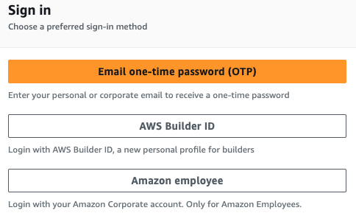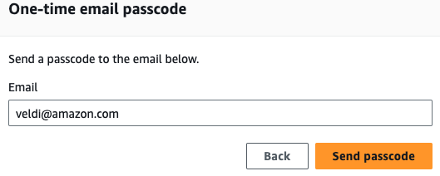

Enter the passcode that you’ve received through email in next screen and click “Sign in”
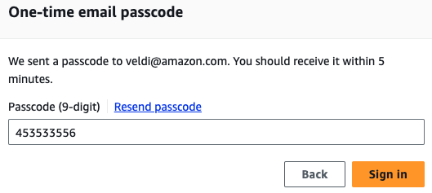

In the next screen, please read and accept the terms and conditions and click on “Join Event”

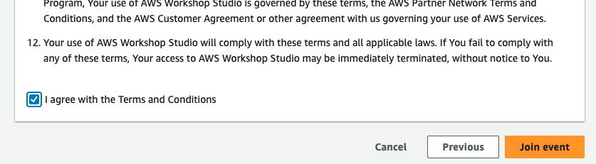

The next screen will be visible ONLY after the event has started. You cannot access the AWS console before the event starts. In the next screen, you’ll see two options for accessing your team specific AWS burner account under the “AWS account access” section in the side bar

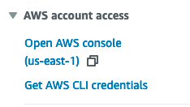

In case you need the AWS CLI credentials for your particular project, you can get those by clicking on “Get AWS CLI credentials”. Most use cases can be handled using the AWS console itself especially this being Hackathon/Prototyping event.

Click on “Open AWS console” and the console page should open in a new tab so that you’ll still have access to original event page in the previous tab.

Important: By default, AWS console should land in the “us-east-1” or “N. Virginia” AWS region. If the console lands in a different region, please switch to the us-east-1 region or else some of the services will not be accessible since this is an AWS burner account.

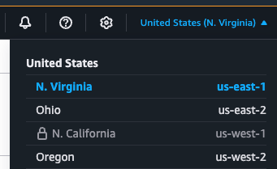

Amazon Bedrock Models Access

Go to the Amazon Bedrock console page for enabling Model Access.

Click on “Enable specific models” and enable the models mentioned in the table below.

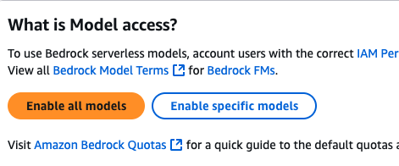

It’s Important to select ONLY the following Foundational Models. These models cater to most of the Gen AI use cases: textual content generation, computer vision and image content generation. Note that this is a prototyping type of AWS Burner account, please DO NOT select anything beyond these models.

Model Name | Purpose
Amazon - Titan Text Embeddings V2 | Textual Embeddings generation
Amazon – Nova Pro | Textual content generation and computer vision
Amazon – Nova Lite | A light weight model that can perform Textual content generation and has computer vision capabilities
Amazon – Nova Canvas | Image content generation
Anthropic - Claude 3.5 Sonnet v2 | Textual content generation and computer vision
Anthropic - Claude 3.5 Haiku | Textual content generation

Please follow below screen recording to enable model access. Once after enabling model access, it’ll take few minutes for the “Access granted” status to show up. Please wait until all these 6 models show the “Access granted” status.

The above setup is only for the model access. You’ll be able to access other features of Bedrock as needed from the console and through API calls. For example: Bedrock Knowledgebases, Guardrails, Agents etc., that can in turn access the enabled models.

Accessing Amazon Q Developer from IDE using builder ID (free version instead of Pro version):

Important: If you need to access the AWS burner account from command line to deploy code or resources from your local machine using your IDE, you need to use the AWS CLI Credentials available to you on the team specific event page (first page shown before you moved onto AWS console).

In the screenshots captured below I’m considering Visual Studio Code as my IDE. You can also use JetBrains IDEs.

First step is to install the “Amazon Q” extension for your specific IDE, instructions are available here. You don’t have to install the AWS Toolkit for this.

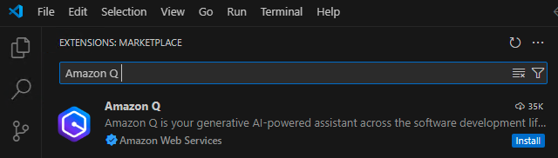

Second step is to “Sigin-in using Builder ID” to access Amazon Q Developer (in IDE). Click on the “Amazon Q” button on the left,



then select “Use For Free No AWS account is required” under the “Choose a sign-in option:” and click “Continue”.

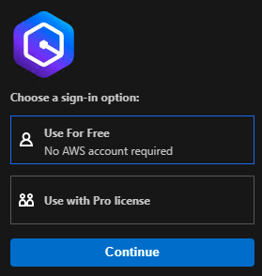

Click on “Proceed To Browser” and “Open” if asked. In the page that opens in Browser, click on “Confirm and continue”. NOTE that the code displayed is unique to you. The one you see in the screenshot is an example.
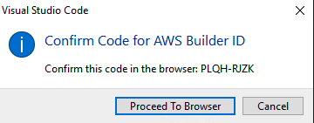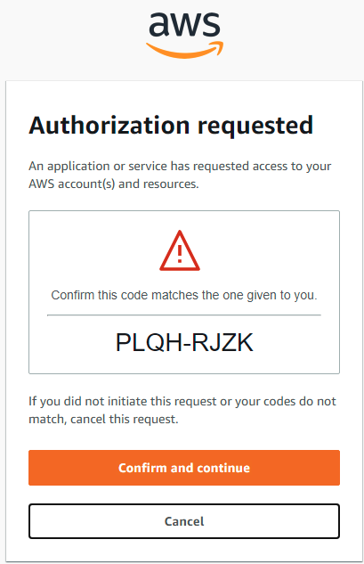

Important: Please use your personal email ID to sign up for the Builder ID instead of Epsilon email ID.

Follow through next set of screens in creating builder ID, email verification, choosing password and Allowing access to AWS IDE Extensions.
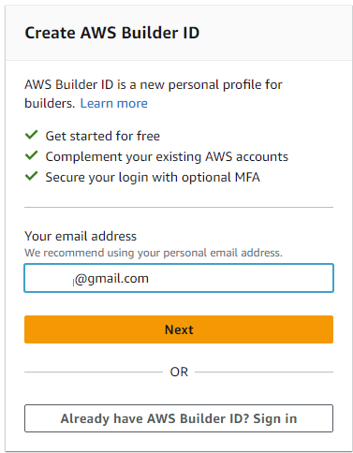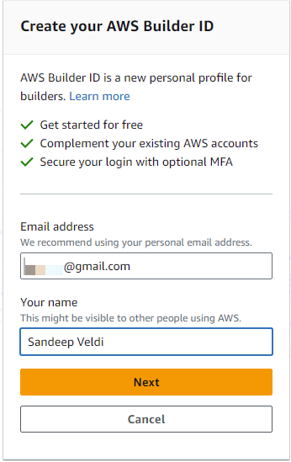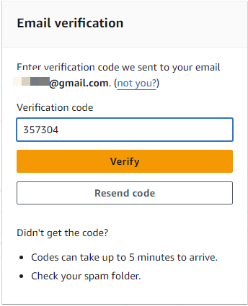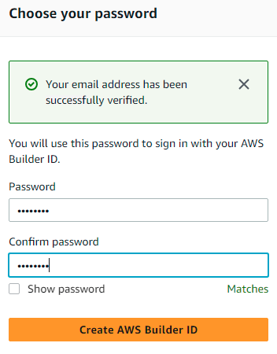

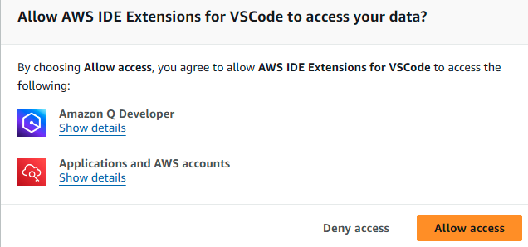

Go back to the IDE, you should be already logged into the Amazon Q using your builder ID. If not, login using the username and password created earlier.

You should now be able to access inline code completions from within the editor as well as leverage Amazon Q Developer Chat feature.

Development instructions and helpful links:

- If you do not have AWS CLI installed on your development machine, you can find the instructions to install it here.
- When you’re developing locally, use the “aws configure” command to configure the “AWS CLI credentials” that you can get from event home page. Pick the CLI credentials in the format that’s applicable for your development machine.
- You can run the “aws configure” command from the terminal window within your IDE, to make the code you’re building aware of the AWS credentials to use when invoking AWS APIs.
- Here are some links with sample code for you to get started quickly.
  - Important Notes:
- If you see any Notebook files in the sample code, you can run those from your IDE, you DO NOT need SageMaker Notebooks to run them. As long as you’ve configured AWS credentials locally as mentioned above, you should be able to interact with AWS APIs through the code in the Notebooks.
- If you see any of the models in code that you’ve not enabled as mentioned above, you can specifically refer to the models you’ve enabled earlier, in the code by finding the corresponding Model IDs. You can find the model IDs by going to the model-catalog page in the AWS Bedrock Console and selecting the specific model that you’ve granted access to earlier.
  - https://github.com/aws-samples/amazon-bedrock-samples/tree/main/multi-modal/Nova
  - https://github.com/aws-samples/amazon-bedrock-samples/tree/main/introduction-to-bedrock/bedrock_apis
  - https://github.com/aws-samples/amazon-bedrock-samples/blob/main/introduction-to-bedrock/cross-region/Getting_started_with_Cross-region_Inference.ipynb
  - https://github.com/aws-samples/amazon-bedrock-samples/tree/main/responsible_ai
  - https://github.com/awslabs/amazon-bedrock-agent-samples
  - https://github.com/vdesaintpern/amazon-bedrock-samples

